**Lab 2 Operational Amplifiers**

**Keegan** **Smith**

**Bench** #19

**Electronics** 1 Lab

**EECE.3110**

**Date submitte**d 03/06/2022

**Due date** 03/06/2022

1. **SUMMARY**

This document reports my findings as well as construction and operation of four types of op-amp circuits using one Op-amp. The constructed circuits include the buffer, inverting op-amp, summing Op-amp and the comparator. An Op-amp buffer allows for a signal to not be affected by a load that a load may have. The inverting Op-amp inverts and amplifies a signal. Summing Op-amps are used to take multiple input currents and combines them into a singular output. Finally, the comparator will output +5V if the positive input is higher than the negative input, he output will be -5V if the negative input is higher than the output and have an output of 0V if both inputs are the same value.

1. **EQUIPMENT**

**Table 1. Equipment**

|  |  |  |
| --- | --- | --- |
| **Equipment Type** | **Details** | |
| * Oscilloscope | *Make:* | InfiniiVision |
| *Model:* | DSO-X2004A |
| *Serial Number:* | MY52161432 |
| * Digital Multimeter | *Make:* | Keithley |
| *Model:* | 2110 5½ |
| *Serial Number:* | 8004026 |
| * DC Power Supply | *Make:* | GWInstek |
| *Model:* | GPD-3303D |
| *Serial Number:* | EM840514 |
| * Function Generator | *Make:* | Tektronix |
| *Model:* | AFG1022 |
| *Serial Number:* | AFG102217331728 |
| * Breadboard * Bench “Shoebox” with connector cables, adapters, clips etc. | N/A | |

**Table 2. Components**

|  |  |  |
| --- | --- | --- |
| **Component Type** | **Quantity** | **Details** |
| Decade resistance box | 1 | N/A |
| TI microchip | 1 | LF353 Operational Amplifier |
| Resistor | 1 | 1k Ω |
| Resistor | 1 | 2k Ω |
| Resistor | 3 | 10k Ω |
| Resistor | 4 | 20k Ω |
| Resistor | 1 | 24k Ω |
| Potentiometer | 3 | 10k Ω |
| Diligent PowerBRICK | 1 | Output +/-9V or +/-12V |

1. **INTRODUCTION**

Digital circuits function in two states, a high and low voltage, or on and off. However, analog circuits do not. This type of circuit operates on continuous, or linear, signals consisting of extremely high or extremely low voltages and everything in between. The Operational Amplifier is one such type of circuit. The output of an Op-amp is dependent on its input, and that ratio can be changed based on two resistors, RIN and ROUT. An Op-amp has two inputs, V- (inverting input) and V+ (non-inverting input), as well as an output VO. Some, such as the comparator, have more than two inputs, but those are used for gain control. During this laboratory we are going to build four types of Op-amp circuits and measure the output to compare them to their ideal, or calculated values.

The Buffer, Figure a. The buffer is an op-amp circuit where VO is shorted to the inverting input and the signal coming in goes into the non-inverting input. The interesting part about the buffer is that it as a gain of 1, meaning the input is equal to the output. The point of this is because an op-amp has an extremely high impedance seen by the output. So, this removes the signal from loading another circuit or the rest of the circuit it’s in.

The Inverting Amplifier, Figure b. The inverting amplifier does what it sounds like, it inverts and amplifies a signal. Unlike the buffer, as seen in Figure b, there is a resistor on the input (RIN) and a resistor on the feedback (RF) loop from VO. VO can be adjusted using these two resistors with the following equation.

(1)

The Summing Amplifier, Figure c. The summing op-amp takes an input current I­IN and adds them together. The circuit is like that of the inverting amplifier, but the summing op-amp does not have an input resistance. Instead, each supply going into the inverting input has its own resistor, hence why we look at current to calculate VO. The equations for this are as follows.

IRF = ∑ VRN / RN (2)

VO = IRF * RF (3)

The Comparator, Figure d. The comparator compares two input voltages and will either have a output of +5V, -5V or 0V. The relationship is when the non-inverting input is greater than the inverting input, the output is +5V. However, when the inverting input is greater than the non-inverting input, the output is -5V. When both inputs are equal, the output is 0V.

1. **CIRCUIT DESCRIPTION**

Figure a.

Figure b.

Figure c.

Figure d.

1. **MEASUREMENTS**

**Table 1. Op-Amp LF353 Specifications**

|  |  |  |  |  |
| --- | --- | --- | --- | --- |
| **Parameter** | **Specified Value** | | | |
| **Min** | **Typical** | **Max** | **Units** |
| Input Offset Voltage (VOS) | N/A | 5 | 10 | mV |
| Input Bias Current (IBias) | N/A | 50 | 200 | pA |
| Input Offset Current (IOS) | N/A | 25 | 100 | pA |
| CMRR | 70 | 100 | N/A | dB |
| Slew Rate | 8 | 13 | N/A | V/µS |

Table 1 presents data taken from page 3, table 3 of the LF353 datasheet (Reference 3).

**Table 2. Buffer Voltage Measurement vs. Calculations**

|  |  |  |
| --- | --- | --- |
| **V­IN** | **VOUT** | |
| Volts (V) | Calculated | Measured |
| +2.0 | +2.0 | +1.984 |
| -2.0 | -2.0 | -1.988 |
| +5 | +5 | +4.959 |
| +7.0 | +7.0 | +5.622 |

Table 2 describes calculated values and measured values of VOUT taken after setting up the circuit in figure a. and adjusting VIN.

**Table 3. Buffer with Decade Box**

|  |  |
| --- | --- |
| **R Value of Decade Box** (Ω) | **Voltage Measurement** (V) |
| 1 | 0.02821 |
| 10 | 0.21918 |
| 100 | 2.1215 |
| 1000 | 4.964 |
| 10000 | ~5 |
| 100000 | 5.008 |
| 1000000 | 4.989 |

Using figure a. and connecting Vout to the decade box as a load, the resistances were changed by an order of magnitude and then the output voltage was measured and recorded.

**Figure 1. Measuring Voltage on Decade Box (10** Ω)

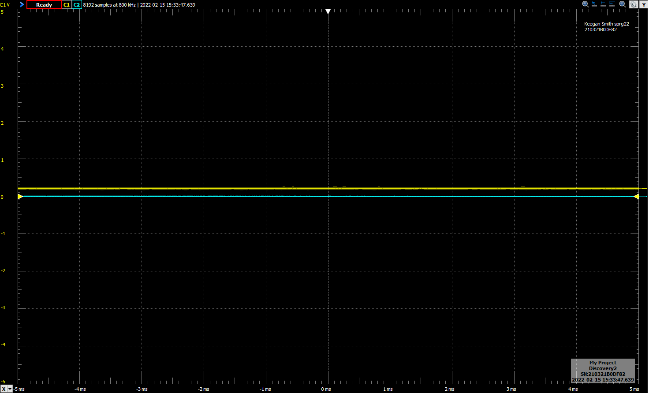

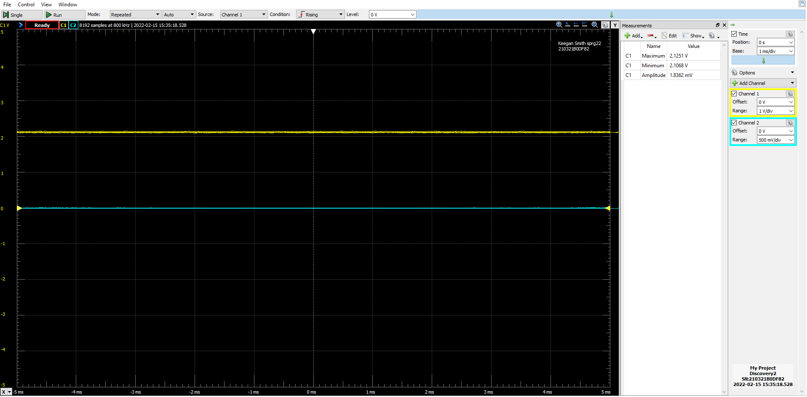**Figure 2. Measuring Voltage on Decade Box (100** Ω)

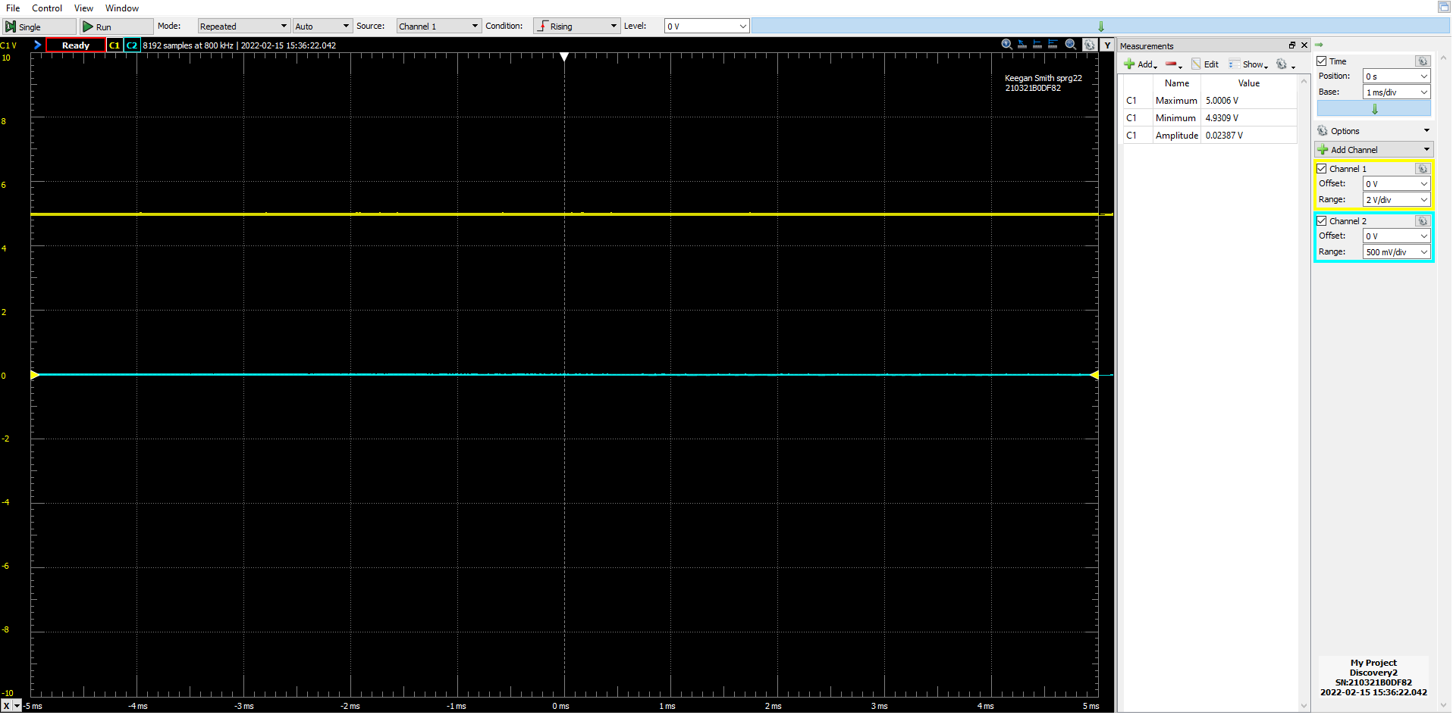**Figure 3. Measuring Voltage on Decade Box (10k** Ω)

**Table 4. Inverting Op-Amp Measurements vs. Calculations with Rf = 10KΩ, RIN = 2KΩ**

|  |  |  |
| --- | --- | --- |
| **Rf = 10KΩ, RIN = 2KΩ** | | |
| **VIN** | **VOUT** | |
| (volts) | Calculated | Measured |
| +0.2 | -1 | -0.973 |
| -0.3 | +1.5 | +1.433 |
| 0 | 0 | -.011 |
| +0.32 | -1.6 | -1.552 |

In table 4, set up figure b. with Rf  equal to 10KΩ and RIN equal to 2KΩ, multiplying the input voltage by about 5.

**Table 5. Inverting Op-Amp Measurements vs. Calculations with Rf = 24KΩ, RIN = 10KΩ**

|  |  |  |
| --- | --- | --- |
| **Rf = 24KΩ, RIN = 10KΩ** | | |
| **VIN** | **VOUT** | |
| (volts) | Calculated | Measured |
| +0.3 | -0.72 | -0.729 |
| -0.25 | +0.6 | +0.596 |
| -0.2 | +0.48 | +0.4754 |
| +0.4 | -0.96 | -0.970 |

Set up figure b. with Rf  equal to 24KΩ and RIN equal to 10KΩ, multiplying the input voltage by about 2.4.

**Table 6. Inverting Summing Op-Amp**

|  |  |  |  |  |
| --- | --- | --- | --- | --- |
| **Input Voltages** | | | **VOUT** | |
| **V1** | **V2** | **V3** | **Calculated** | **Measured** |
| +1 | +1 | +1 | -3 | -2.976 |
| -1 | -1 | +1 | +1 | +0.976 |
| -1 | -1 | +2 | 0 | -0.0187 |
| +3 | -3 | -3 | +3 | +2.954 |
| -2 | +1 | -2 | +3 | 2.956 |

Table 6 uses figure c. and shows the calculated and measured values of Vout . The results are when three input voltages are applied to the inverting input of the op-amp.

**Table 7. Comparator**

|  |  |  |  |
| --- | --- | --- | --- |
| **Input Voltages** | | **Output Voltages** | |
| **V1** | **V2** | **Calculated** | **Measured** |
| +4 | +1 | -5 | -4.728 |
| +2 | +3 | 5 | 5.416 |
| +1 | 0 | -5 | -4.728 |
| +4 | +4 | 0 | 5.4 |
| 0 | +1 | 5 | 5.416 |
| +3 | +2 | -5 | -4.7307 |

This table visualizes the output of figure d. when different voltages are applied to V1 and V2.

**Table 8. Slew Rate of Op-Amp Analog Discovery vs. Oscilloscope**

|  |  |  |  |  |  |  |
| --- | --- | --- | --- | --- | --- | --- |
| **(V/µS)** | **Rise time measurement number** | | | | |  |
| **Device** | **1** | **2** | **3** | **4** | **5** | **Average** |
| **Analog Discovery** | 12.545 | 11.55 | 6.0287 | 16.316 | 7.7191 | 10.83176 |
| **Oscilloscope** | 11.84188 | 15.41186 | 22.5378 | 11.2086 | 11.8085 | 14.6173 |

Table 8 uses figure a., the buffer op-amp configuration to show the slew rate of the IC chip. Five measurements and the average were taken on both devices.

**Figure 4. Measuring Slew Rate with Analog Discovery**

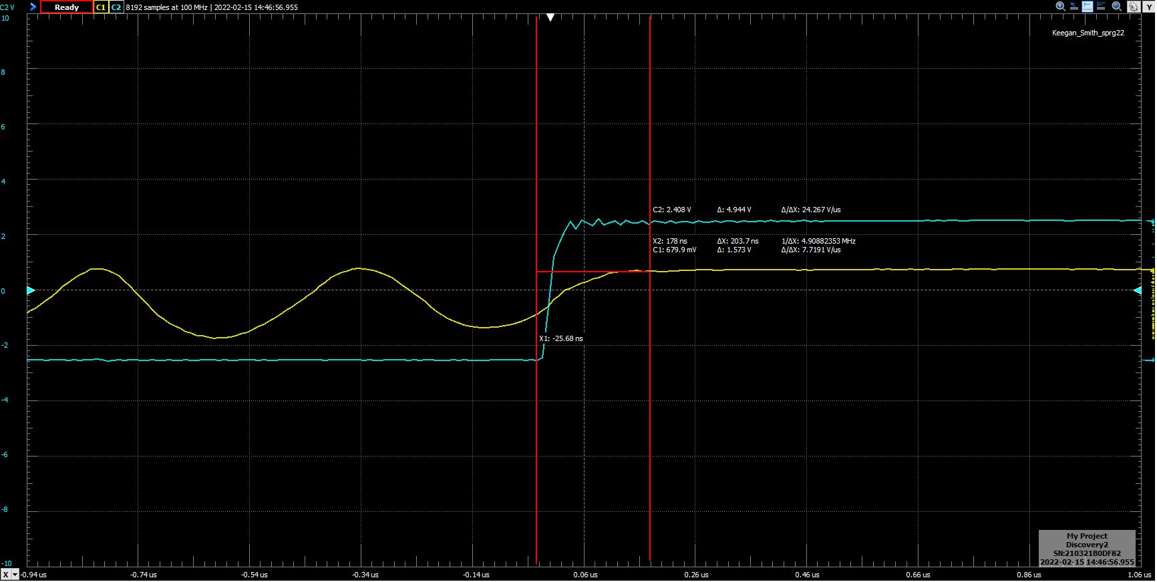

**Figure 5. Buffer**

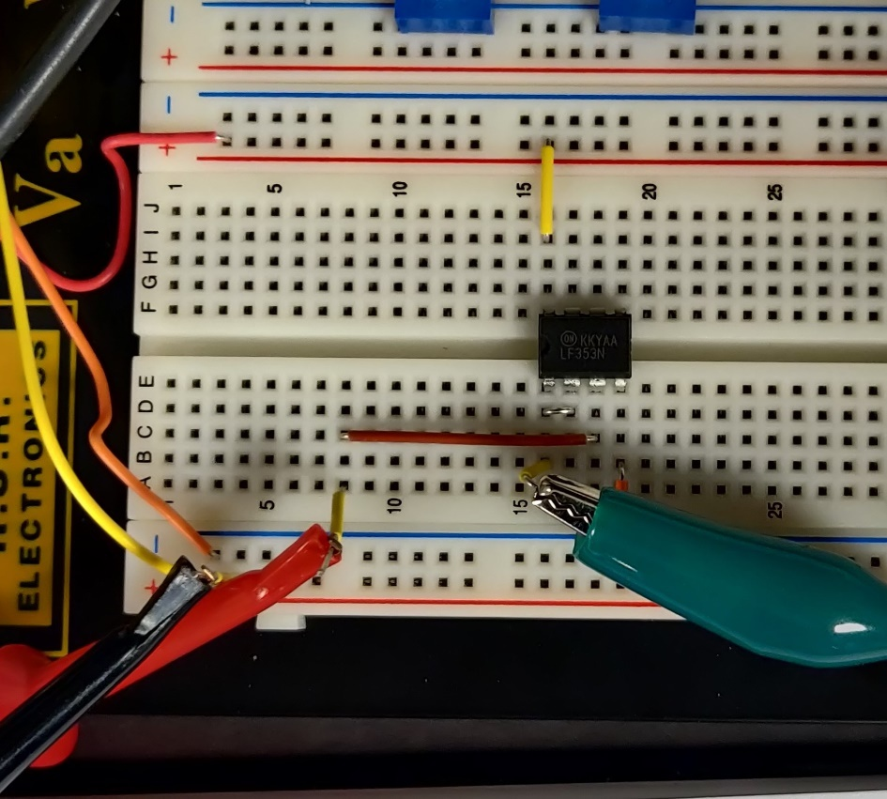

**Figure 6. Inverting Op-Amp Rf = 10k** Ω

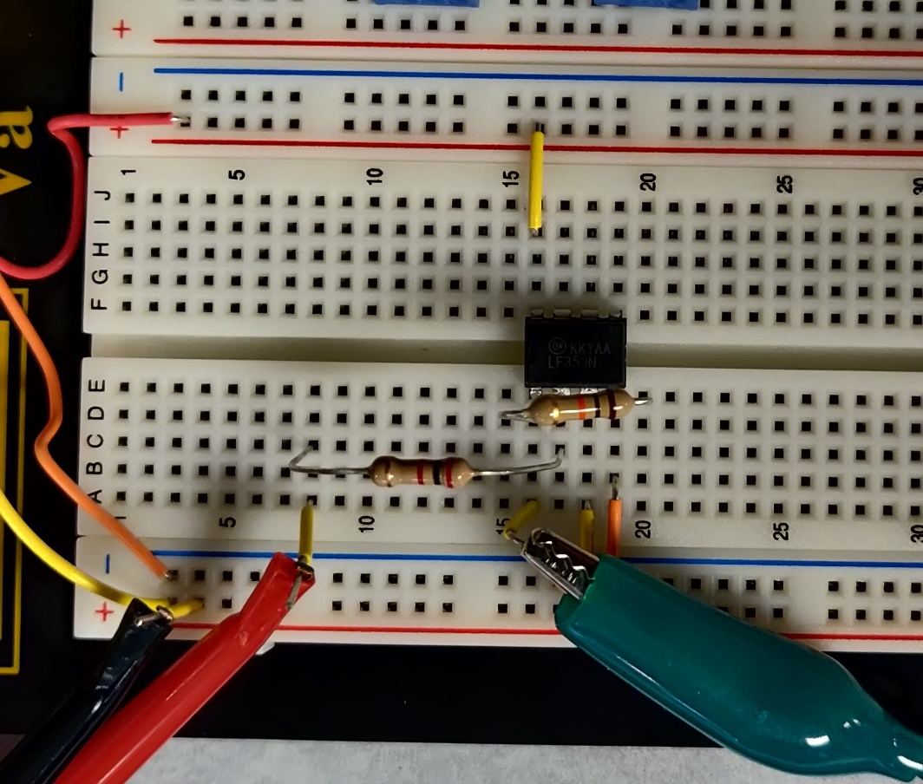

**Figure 6. Inverting Op-Amp Rf = 24k**

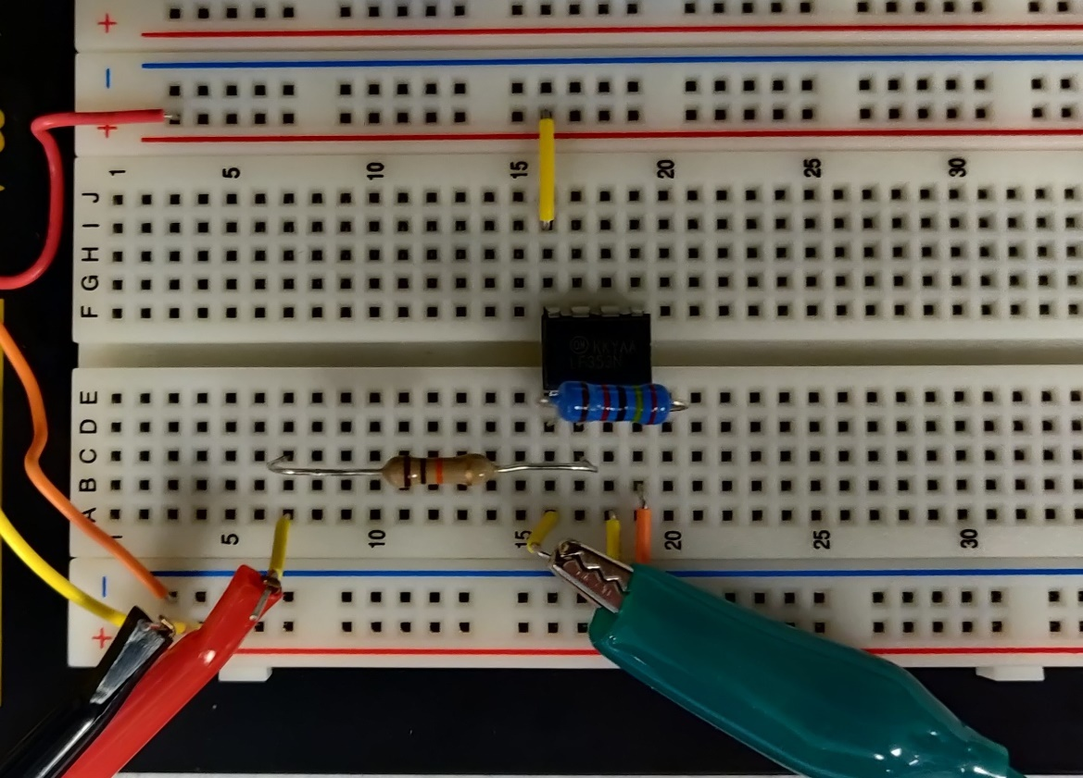

**Figure 8. Summing Op-Amp**

**Figure 9. Comparator**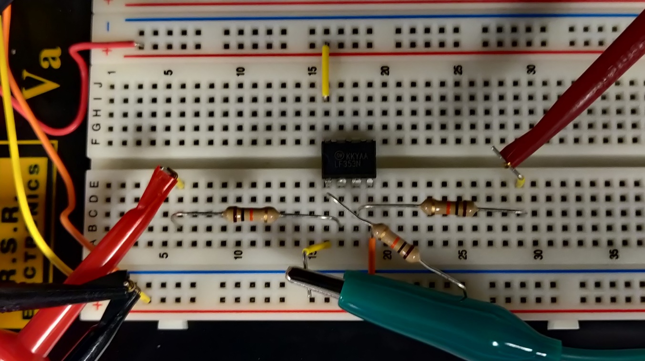

**Figure 10. Slew Rate Measurement on Oscilloscope**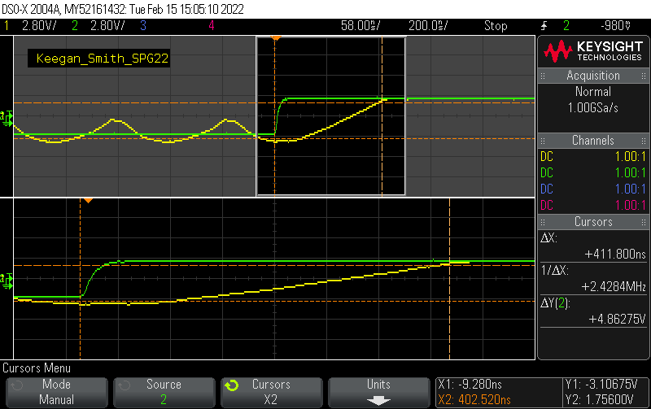

1. **DISCUSSION**

The buffer configuration of an Operational Amplifier is used to create a disconnect between a signal and load without affecting the signals clarity. I observed a small voltage drop across the op-amp, but at higher voltages this would be negligible. For example, the highest drop I recorded was 0.03 volts. The more interesting part of the buffer circuit was a discrepancy seen when VIN was set to +7v, the output was 5.622v. This is due to the op-amp being limited to its rail voltage. Positive Vcc and negative Vcc were set to 6.2v respectively so, the output cannot go about that. The max output of 5.622v would be due to voltage losses through the internal circuitry of the amplifier.

In part d of the buffer section of the procedure, the output of the buffer is connected to a decade box. A decade box can be used to adjust resistances however the user seems fit. During this changes the gain of the buffer, which is normally infinity. For example, when the decade box was set to 1Ω the output voltage was around 28mv. However, as the resistance was increased, nearing infinity, the voltage began to increase to the 5v input voltage.

The output of an inverting operational is given by equation (1), . For the first configuration the output voltage expected was 5 times that of VIN. This is seen in table 4. In part e of the inverting op-amp changes Rf / RIN from 5 to 2.4. The jump down in amplification can be seen in table 5.

Section three pertains to testing the op-amp in a summing amplifier configuration. Using a combination of equations 2 and 3. If using the same resistors for Rn and Rf, the gain is set to 1 so, there is no amplification. This allows for head math of what to expect for the output. For example, the first row in table 6 has all input voltages set to +1v so, the output would be 3v +/- a few millivolts.

One of the more interesting applications of an op-amp is the comparator. The Comparator has two inputs, V1 and V2, each with their own resistors. The comparators output depends on the more dominate input. For example, when V1 is higher than V2, VO is equal to -5v and, when V2 is greater, VO is +5v. However, when both inputs are equal, the output is 0v, but in truth this does not work. Looking at table 7, when the inverting input is higher, the output is a little under -5v and when the non-inverting input is higher, the output is a little higher than +5v. However, when both inputs are set to the same voltage, the output is 5v! This is because on paper calculations are done with idealities that do not exist in practical application so, the input voltages are never actually equal and constantly fluctuates the output between +5v and -5v.

During the slew rate measurement portion of the procedure there were some issues. The slew rate was not consistent on either devices and as seen in the table 8, the oscilloscope and the Analog Discovery measured different slew rates. Five measurements were taken for 5 different single triggers on both devices and then averaged for the particular device. This generated two numbers that fit in the range supplied in the LF353 data sheet (reference 3). However, the averaged slew rate calculated from the oscilloscopes measurements was high. This is likely due to having to set cursers by eye to record a measurement that looked right (figure 1). To calculate the slew rate on the oscilloscope the formula ∆Y/∆X. On the Analog Discovery, the cursors had the function built in (where the formula was gotten from) allowing for more accurate readings.

1. **CONCLUSION**

The objective of the lab was to observe the different functionalities of an operational amplifier was to develop some of my first digital/analog circuits such as the buffer, inverting operational amplifier, summing amplifier, and the comparator. Each circuit construction reenforced their mathematical/ideal counter parts and how they interact in real life, such as when the comparator would not enter the state of off when both inputs are the same voltage.

1. **QUESTIONS**
2. The LM741C is identical to the LM741/LM741A except that the LM741C has their performance specifications limited to 0⸰C <= Ta <= +70⸰C.
3. An analog signal can vary at any value between the low and high voltage range supplied by the power supply.
4. A linear circuit produces signals that are analog.
5. When the voltage applied to a non-inverting terminal of an op-amp comparator is less than the voltage at the inverting input, the output will be driven to positive saturation.
6. If -2v is applied to an inverting op=amp that has an input resistance of 2k ohm and a feedback resistance of 5k ohm, the voltage at the output is 5v and the polarity is negative.
7. A summing op-amp of figure c has the following applied inputs, +2v, +3v, -1v, the output would be +4v.
8. **REFERENCES**
9. Wikipedia contributors. “Buffer Amplifier.” *Wikipedia*, en.wikipedia.org/wiki/Buffer_amplifier#:%7E:text=A%20buffer%20amplifier%20(sometimes%20simply,load%20may%20be%20produced%20with.
10. LF353 datasheet “LF353 Datasheet.” *ST*, ST, www.st.com/content/ccc/resource/technical/document/datasheet/34/f6/2b/8b/3e/cf/44/b8/CD00000454.pdf/files/CD00000454.pdf/jcr:content/translations/en.CD00000454.pdf.
11. “LM742 Datasheet.” *Texas Instruments*, Texas Instruments, July 1998, <https://www.ti.com/lit/ds/symlink/lm741.pdf>
12. Circuit pictures for figures a, b, c, and d were taken from the laboratory procedure